23-30 APRIL
Vaccination Week in the Americas

FINAL REPORT 2022

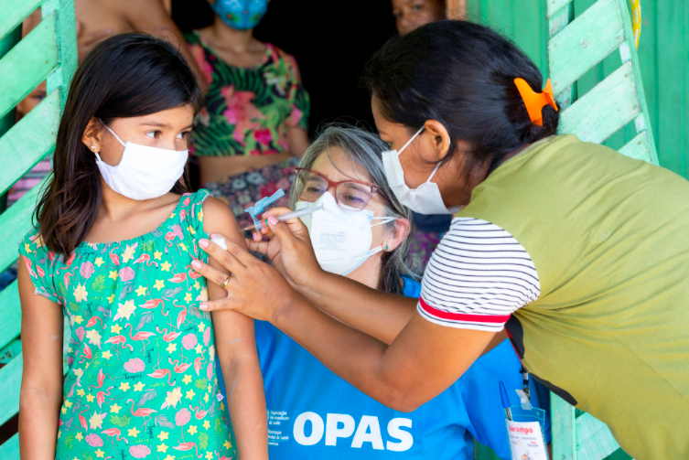
Are you fully vaccinated?
#GetAllYourShots #VWA20

www.paho.org/vwa
PAHO/WHO
@pahowho
(insert name of country)

Vaccination Week in the Americas 2022
FINAL REPORT
Return to PAHO by 31 August 2022
Country
Summarize in a short paragraph how your country celebrated VWA 2022.

Launching Events
Date | In-Person/Virtual | Level (Local, National, other) | Invited guests (from government, UN agencies, civil society, celebrities, etc.) | Additional info (link to recording)

Number of people vaccinated by population
Please enter the number of persons vaccinated per age group.
0-12 months | 1-4 years | <5 years | > 5 years | WCBAs | Adults | >60 years | High risk occupations | Health Care Workers | Others | TOTAL
Comment/Explanation (if needed):

Goals by Antigen
Please enter the number of persons vaccinated with each antigen.
COVID-19 | Measles  Mumps Rubella (MMR) | Measles and Rubella (MR) | Polio bOPV | Polio  IPV | Yellow Fever | Influenza | Diphtheria, Tetanus, Pertussis (DTP) | Diphtheria Tetanus  (<7 yrs)  (DT)
Tetanus diptheria (>7 yrs)  (Td) | Haemophilus influenzae type b  (Hib) | Hepatitis B | Penta-valent | BCG | Rotavirus | Pneumo | HPV | Other
Comment/Explanation (if needed):

Vaccination goals for specific populations
Please enter the number of municipalities in which you vaccinated specific populations (indigenous, afro-descendants and border areas)
Number of border municipalities |  |  |  |  |  | Number of municipalities where the majority of the population identify as indigenous and afro-descendants
Comment/Explanation (if needed):
Number of individuals vaccinated living in at-risk municipalities (indigenous, afro-descendants)
Please enter the number of persons vaccinated per age group
0-12 months | 1-4 years | <5 years | > 5 yo | WCBAs Td | Adults | >60 years | High risk occupations |  | Health Care Workers |  | Others |  | TOTAL
Comment/Explanation (if needed):
Number of individuals vaccinated living in at-risk municipalities (border areas, migrant communities)
Please enter the number of persons vaccinated per age group
0-12 months | 1-4 years | <5 years | > 5 yo | WCBAs Td | Adults | >60 years |  | High risk occupations |  | Health Care Workers |  | Others | TOTAL
Comment/Explanation (if needed):

COVID-19 Vaccination
During VWA 2022, countries used the platform as an opportunity to promote and reach their population with COVID-19 vaccines and close the gaps in groups left behind.
Did your country used VWA 2022 to vaccinate people against COVID-19? |  |  |  |  |  | Yes  ☐ | No  ☐
Indicate which methods your country used to reach the population and which groups were prioritize:
Number of people vaccinated
Health Care Workers | Other essential personnel | Older adults  (>60 yo) | Persons >18 yo | People with underlying health conditions | Persons <18 yo | Total

Flu Vaccination
VWA 2022 focused on prioritizing influenza vaccination to prevent respiratory illness or hospitalizations caused by influenza in countries where the influenza season began, and thus supporting the response efforts of the COVID-19 pandemic.
Indicate whether your country prioritized influenza vaccination, which methods were used to reach the population, how many people were vaccinated, and which groups were prioritized. |  |  |  |  |  |  | Yes  ☐ | No  ☐
Comment/Explanation (if needed):

Number of people vaccinated
Children under 5yo | Pregnant Women | People with chronic diseases | Older adults 60+ | Health Care Workers | Others | Total

Measles Vaccination
VWA 2022 was a great opportunity for all the countries of the Region to implement activities to end the current outbreaks of measles, protect their communities, and permanently eliminate the measles virus in the Americas.
Protect the achievement of measles elimination  Did you carry out activities to protect the elimination of measles in your country? |  | Yes  ☐ | No  ☐
How many children did you vaccinate?
What ages?
Were adults vaccinated against measles? | Yes ☐ No ☐
How many? | Number: _______

Campaign Specifics
Adapting the campaign
Please describe what steps, if any, did the country take to adapt the VWA campaign, taking into account the global epidemiological situation, the COVID-19 pandemic and countries’ public health measures being implemented (e.g. rearranging vaccination services, personal and community protective measures, vaccination in special and non-conventional places, specific messaging for the population regarding the importance of vaccines during the pandemic, etc.)
Sustaining the achievements  Indicate if your country carried out activities to protect achievements (e.g.: maintaining elimination of diseases, completion of childhood schedules, etc.), and then briefly describe plans the space below | Yes  ☐ | No  ☐
Completing the unfinished agenda in order to prevent and control vaccine-preventable diseases  Indicate if your country carried out activities to complete the unfinished agenda (e.g.: seasonal influenza prevention, elimination of neonatal tetanus, protection of occupational risk groups, hep. B elimination, etc.), and then briefly describe plans in the space below. | Yes  ☐ | No  ☐
Strengthen health services for effective vaccine administration  Indicate if your country carried out activities to strengthen health services. | Yes  ☐ | No  ☐
Vulnerable Population Group Activities  Indicate if your country carried out activities to target vulnerable population groups, and then briefly describe the type of activities and the planned target groups in the space below. | Yes  ☐ | No  ☐

Social Mobilization and Communication Activities
Did you use the Regional slogan, “Closing the Gaps. #GetVax”? | Yes  ☐ |  | No  ☐
Did you develop other targeted messages/slogans? This can include the adaptation of slogans into indigenous languages. Describe below. | Yes  ☐ |  | No  ☐
Did your country develop additional communicational/promotional materials (e.g.: brochures, posters, t-shirts, etc.)? Describe below. | Yes  ☐ |  | No  ☐
Did your country carry out activities to improve public awareness and health literacy regarding the importance of immunization and vaccines? (e.g.: Webinars, forums, videos). Describe below. | Yes  ☐ |  | No  ☐
Were there press releases for media attention? Describe below. | Yes  ☐ |  | No  ☐
Did you use social media (Facebook/Twitter) to promote VWA? Please describe below and share posts with highest impact. | Yes  ☐ |  | No  ☐
Did you document activities through photos, videos, and other audiovisual materials? Please share links and indicate if you have permission form the people in them. | Yes  ☐ |  | No  ☐
Did you capture images of the materials being used in public spaces such as health clinics, school, or others? |  | Yes  ☐ |  | No  ☐
Please send us links to all materials developed so we can include them in the final report.

Risk Communications and Community Engagement
Did you use VWA to promote messages on the following?
1) the safety of vaccines | Yes  ☐ | No  ☐
2) the effectiveness of vaccines | Yes  ☐ | No  ☐
3) how vaccines are developed | Yes  ☐ | No  ☐
4) in the case of COVID-19 vaccination, prioritized groups for vaccination | Yes  ☐ | No  ☐
5) challenges related to immunization | Yes  ☐ | No  ☐
Did you engage in any social listening activities to monitor and address rumors and doubts about immunization? Please list/describe below: | Yes  ☐ | No  ☐
Did you train health care workers on interpersonal communication, including how to respond to rumors and doubts about immunization? Please describe below: | Yes  ☐ | No  ☐
Did you use VWA to engage key stakeholders about immunization, including at the community level? Please describe below. (i.e.: collaboration with civil society organizations, religious leaders, professional and patient associations, and others) | Yes  ☐ | No  ☐

Integrated Activities
Will your country involve integrated interventions (non-vaccination related) during VWA? (e.g.: COVID-19 prevention measures awareness, health screening, and health education). Please describe below the type of activity and targeted audience. | Yes  ☐ | No  ☐

Evaluation Activities
Countries are highly encouraged to undertake short surveys during VWA; a proposed template can be found on the website (see direct link below), followed by a model survey for evaluating VWA social communication campaigns (see direct link below).
Did you use Vaccination Week in the Americas as a platform to monitor public satisfaction with vaccination? Describe below. | Yes  ☐ | No  ☐
Did you conduct any evaluation activities for VWA? (e.g.: administration coverage, assessment of public satisfaction with vaccination, vaccine confidence, evaluation of VWA social communication campaigns, targeted coverage surveys). Describe below | Yes  ☐ | No  ☐

Annexes
Please attach any additional information you would like to share.

